  How to Balance your chakras to prevent overwhelm | Feel better minutes  Bringing greater peace and emotional control into your every day life.  Debra Jamieson  Reiki/Seichem Master Teacher

Contents
WHAT ARE CHAKRAS? 2
WHERE ARE THE CHAKRAS LOCATED IN YOUR BODY? 3
SOUND, MANTRAS (Vibration) 5
CRYSTALS 7
ESSENTIAL OILS 9
RECORDED MEDITATION 11



WHAT ARE CHAKRAS?

Chakras are considered energy centres within the body that originate from ancient Indian spiritual traditions, specifically from practices like yoga, Ayurveda, Reiki and Seichem. The word "chakra" comes from Sanskrit and means "wheel" or "disk," signifying the spinning energy in these centres.
Balancing your chakras can offer a range of benefits, enhancing your physical, emotional, mental and spiritual well-being. Here are some of the major benefits:
- Improved Physical Health: Each chakra is associated with specific organs and systems in the body. Balancing them can help alleviate physical ailments related to those areas, promoting overall health.
- Emotional Stability: Balanced chakras can lead to better emotional regulation, helping you manage stress, anxiety, and depression more effectively. You’ll feel more grounded and emotionally resilient.
- Enhanced Mental Clarity: When your chakras are aligned, you may experience improved focus, concentration, and mental clarity. This can boost your productivity and your ability to make decision.
- Spiritual Growth: Balancing your chakras can deepen your connection to your higher self and the universe. It can enhance your intuition, spiritual awareness, and sense of purpose.
- Better Relationships: A balanced chakra system can improve how you interact with others. You'll be more open, compassionate, understanding, and not take things so personally, leading to healthier and more fulfilling relationships.
- Increased Energy Levels: When your chakras are in harmony, your energy flows more freely, resulting in increased vitality and reduced fatigue.
- Enhanced Creativity: A balanced sacral chakra, in particular, can boost your creativity and inspire you to express yourself more freely in various artistic pursuits.
So, balancing your chakras isn’t just about feeling zen; it's about promoting holistic well-being and one of the keys to unlocking your full potential.
In this book I will be discussing the main 7 chakras within the body. These wheels of energy can be to empty, overactive, underactive or sometimes spinning at different rates which causes an imbalance. When this happens, we can feel different emotions, think differently and even have physical ailments when left unattended for a longer period of time. The aim is to balance them and have them spinning at the same rate.
It’s important because how balanced we are can have an impact on our day goes. For instance, we have all heard the saying “I got out of the wrong side of the bed this morning”. This can happen to all of us. Unfortunately for many the day continues this way, as they continue to attract from this undesired state. However, if you took a couple of minutes to balance your chakras, your day would improve from that moment on.
Another example would be where you on the receiving of someone who “got out of the wrong side of the bed”. They snap at you and you are left feeling uneasy. You know you are not the problem, but what often happens, especially if we are caught off guard, the solar plexus chakra will empty and it leaves a sense of uncertainty. Again, spending a couple of minutes balancing and aligning your chakras will get back to feeling good. Promoting overall health; Practices like meditation, yoga, and energy healing often aim to balance and harmonize these energy centre.
This will be a great tool to bring self-awareness and bring more peace and stability in your life. That might sound like a bold statement, however, spending time focusing on what is going on internally for yourself will always bring about more changes than focusing externally. Internal is where the power is.

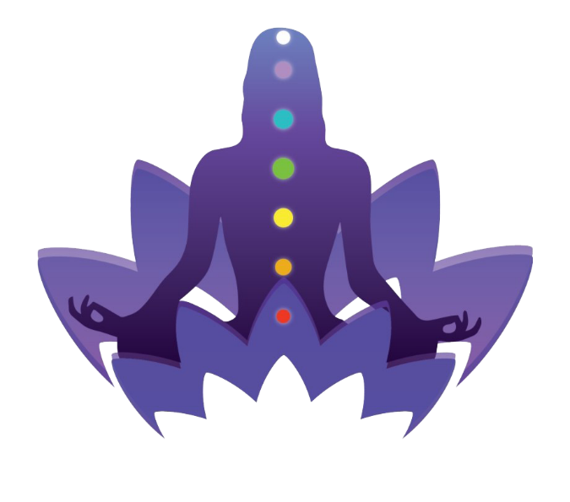

WHERE ARE THE CHAKRAS LOCATED IN YOUR BODY?
1. Root Chakra (Muladhara)
Location: Base of the spine
Associated with: Basic survival needs, security, and grounding
Colour: Red

2. Sacral Chakra (Svadhisthana):
Location: Lower abdomen, about two inches below the navel
Associated with: Creativity, sexual energy, and pleasure
Colour: Orange

3. Solar Plexus Chakra (Manipura):
Location: Upper abdomen, around the stomach area
Associated with: Personal power, self-esteem, and confidence
Colour: Yellow

4. Heart Chakra (Anahata):
Location: Centre of the chest
Associated with: Love, compassion, and relationships
Colour: Green

5. Throat Chakra (Vishuddha):
Location: Throat
Associated with: Communication, self-expression, and truth
Colour: Blue

6. Third Eye Chakra (Ajna):
Location : Forehead, between the eyes
Associated with: Intuition, insight, and imagination
Colour : Indigo

7. Crown Chakra (Sahasrara):
Location : Top of the head
Associated with: Spiritual connection, enlightenment, and consciousness
Colour : Violet or white

SET AN INTENTION
Have something in mind that you would like being brought about, without having any attachment to how this happens, to be neutral in a sense, so to allow something even greater to show up. To be in a state of neutrality is to allow the best possible outcome. Aesop’s Fable, the old man and death teaches us “be careful what you wish for, you just might get it.” Often when we are problem solving, we are focused on what we don’t want.

4 WAYS TO QUICKLY BALANCE YOUR CHAKRAS
Balancing your chakras is easy to learn and easy to do. However, it will take some regular practice at the beginning in order to become more aware of what is going on inside you and how to effectively make the desired changes.
Being a Reiki/Seichem Master Teacher for over 20 years, I would always say the best way is to be attuned into these modalities of energy healing. The problem with that is that it would leave way too many people unable to have a technique to quickly bring more peace and serenity into their daily lives. Something to use anywhere, anytime, hence I am sharing these methods here.
As you balance your chakras on a regular basis, you will quickly become to know where they are, what colour they are and what is need to align them more and more easily.


This Photo by Unknown Author is licensed under CC BY-NC-ND

SOUND, MANTRAS (Vibration)
Mantras are powerful tools for balancing and activating the chakras. Here’s an expanded look at each chakra and its corresponding mantra:

1. Root Chakra (Red)
- Location: Base of the spine
- Mantra: LAM
- Meaning: The root chakra is all about grounding and security. Chanting "LAM" helps to stabilize and energize this chakra, fostering a sense of safety and belonging.

2. Sacral Chakra (Orange)
- Location: Lower abdomen, about two inches below the navel
- Mantra: VAM
- Meaning: The sacral chakra governs creativity, pleasure, and emotions. Chanting "VAM" can enhance your creative flow and emotional well-being, promoting a healthy expression of desires and feelings.

3. Solar Plexus Chakra (Yellow)
- Location: Upper abdomen, around the stomach area
- Mantra: RAM
- Meaning: The solar plexus chakra is linked to personal power and confidence. Chanting "RAM" empowers this chakra, boosting self-esteem and motivation.

4. Heart Chakra (Green)
- Location: Centre of the chest
- Mantra: YAM
- Meaning: The heart chakra is the centre of love and compassion. Chanting "YAM" helps open your heart to unconditional love, empathy, and emotional balance.

5. Throat Chakra (Blue)

Location: Throat
- Mantra: HAM
- Meaning: The throat chakra is associated with communication and self-expression. Chanting "HAM" enhances your ability to speak your truth and communicate effectively.

6. Third Eye Chakra (Indigo)
- Location: Forehead, between the eyes
- Mantra: OM (or AUM)
- Meaning: The third eye chakra is related to intuition and insight. Chanting "OM" helps to activate and balance this chakra, enhancing your intuition and inner wisdom.

7. Crown Chakra (Violet)
- Location: Top of the head
- Mantra: Silent OM (simply thinking the sound "OM" without vocalizing it)
- Meaning: The crown chakra is your connection to higher consciousness and spiritual enlightenment. Meditating on a silent "OM" can help you connect with the divine and achieve a state of pure awareness.

How to Use Mantras
- Find a Quiet Space: Sit comfortably in a quiet place where you won’t be disturbed.
- Focus on the Chakra: Visualize the location and colour of the chakra you’re working on.
- Chant the Mantra: Inhale deeply, and as you exhale, repeat the mantra associated with that chakra. You can chant it aloud or silently in your mind. I prefer to chant out loud if possible. (In the bathroom at work may bring some unwanted attention, hee hee).
- Feel the Vibration: Focus on the vibration of the sound resonating within the chakra.
- Consistency: Practice regularly to deepen your connection and balance your chakras more effectively.
Using these mantras can help you align and harmonize your energy centres. You can even do them while driving in the car. In no time at all you will be able to feel the sound of the mantra vibrate inside you. Enjoy your mantra practice and notice what changes occur.

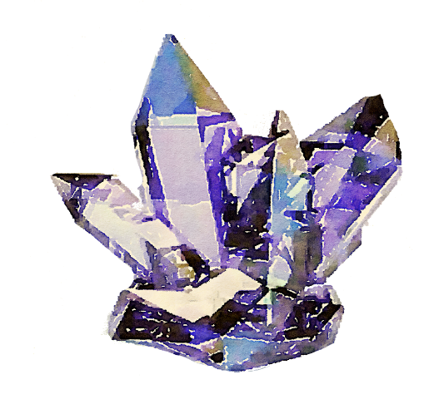
This Photo by Unknown Author is licensed under CC BY

CRYSTALS
Crystals are a fantastic way to support the balance and alignment of your chakras. Here’s a detailed guide on the crystals associated with each chakra and how they can help balance them:
1. Root Chakra (Red):
- Red Jasper: Grounding and stabilizing, enhances endurance.
- Hematite: Protects and strengthens, brings focus.
- Smoky Quartz: Detoxifying and grounding, relieves stress.
- How to Use: Place near the area at the base of your spine or carry with you to promote grounding and stability.

2. Sacral Chakra (Orange)
- Carnelian: Stimulates creativity and vitality.
- Orange Calcite: Enhances joy and passion.
- Amber: Cleanses and energizes, promotes a positive outlook.
- How to Use: Place on the lower abdomen or wear as jewellery to stimulate creativity and pleasure.

3. Solar Plexus Chakra (Yellow)
- Citrine: Boosts confidence and personal power.
- Tiger’s Eye: Encourages courage and strength.
- Yellow Jasper: Nurtures and empowers, promotes self-discipline.
- How to Use: Place on the upper abdomen or carry with you to enhance confidence and motivation.

4. Heart Chakra (Green)
- Rose Quartz: Promotes unconditional love and emotional healing.
- Green Aventurine: Encourages compassion, emotional balance and prosperity.
- Emerald: Enhances love and harmony, brings emotional balance.
- How to Use: Place on the heart area or wear as a pendant to foster love and compassion.

5. Throat Chakra (Blue)
- Blue Lace Agate: Enhances communication and clarity.
- Aquamarine: Calms and promotes truthful expression.
- Sodalite: Encourages rational thought and verbal expression.
- How to Use: Place on the throat area or wear as jewellery to support clear communication.

6. Third Eye Chakra (Indigo)
- Amethyst: Enhances intuition and spiritual awareness.
- Lapis Lazuli: Promotes insight and clarity of thought.
- Fluorite: Improves focus and spiritual growth.
- How to Use: Place on the forehead or meditate with the crystal to enhance intuition and insight.

7. Crown Chakra (Violet)
- Clear Quartz: Amplifies spiritual energy and clarity.
- Selenite: Connects to higher consciousness and angelic realms.
- Amethyst: Also beneficial for the crown chakra, promotes spiritual awakening.
- How to Use: Place on the top of your head or meditate with the crystal to connect with higher consciousness.

How to Use Crystals for Chakra Balancing
- Meditation: Hold the crystal or place it on the corresponding chakra during meditation.
- Jewellery: Wear the crystals as necklaces, bracelets, or rings to keep their energy close to you.
- Sleep: Place crystals under your pillow or beside your bed to work on your chakras while you sleep.
Incorporating crystals into your chakra balancing routine can enhance your energetic alignment and promote overall well-being. Enjoy exploring their vibrant energies!


This Photo by Unknown Author is licensed under CC BY-NC

ESSENTIAL OILS
Essential oils can be a wonderful addition to your chakra balancing routine. Each oil has properties that resonate with specific chakras, helping to align and balance them. Here’s a guide to essential oils for each chakra:
1. Root Chakra (Red)
- Cedarwood: Grounding and stabilizing.
- Patchouli: Promotes a sense of security.
- Vetiver: Earthy and grounding, helps with focus.
- How to Use: Apply to the soles of your feet or lower back, or use in a diffuser.

2. Sacral Chakra (Orange)
- Ylang Ylang: Enhances creativity and sensuality.
- Sandalwood: Calms and balances emotions.
- Sweet Orange: Uplifting and promotes joy.
- How to Use: Apply to the lower abdomen, add to a bath, or diffuse.

3. Solar Plexus Chakra (Yellow)
- Lemon: Energizing and uplifting.
- Ginger: Enhances confidence and motivation.
- Peppermint: Stimulates and refreshes.
- How to Use: Apply to the solar plexus area, inhale directly, or diffuse.

4. Heart Chakra (Green)
- Rose: Opens the heart to love.
- Lavender: Calming and promotes emotional balance.
- Bergamot: Uplifting and helps with emotional release.
- How to Use: Apply to the heart area, diffuse, or add to a bath.

5. Throat Chakra (Blue)
- Peppermint: Clears and stimulates communication.
- Eucalyptus: Opens the airways and enhances expression.
- Chamomile: Soothes and promotes truthful communication.
- How to Use: Apply to the throat area, inhale directly, or diffuse.

6. Third Eye Chakra (Indigo)
- Frankincense: Enhances spiritual awareness and intuition.
- Clary Sage: Promotes clarity and vision.
- Sandalwood: Calming and aids in meditation.
- How to Use: Apply to the forehead or temples, inhale, or diffuse.

7. Crown Chakra (Violet)
- Lavender: Calms and opens the mind to higher consciousness.
- Frankincense: Connects with spiritual realms.
- Rosewood: Uplifts and aligns with divine energy.
- How to Use: Apply to the crown of the head, it can also be used in meditation, or in a diffuser.

How to Use Essential Oils for Chakra Balancing
- Topical Application: Dilute with a carrier oil (like coconut or jojoba oil) and apply to the chakra area.
- Aromatherapy: Use a diffuser to spread the essential oil aroma throughout your space.
- Bath: Add a few drops to your bathwater for a relaxing and balancing soak.
- Inhalation: Inhale directly from the bottle or put a few drops on a tissue or cotton ball.
- Note: Be careful with essential oils, they are very potent. Less is more. It can be toxic to use too much, especially around children and animals that are even more sensitive.
Incorporating these essential oils into your chakra balancing practice can enhance your overall energy flow and promote physical, emotional, and spiritual well-being. Not to mention the delightful scents. Beneficial to your health, unlike fragrances. Enjoy.

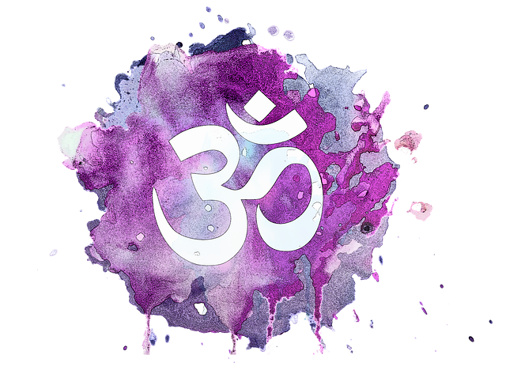

RECORDED MEDITATION
Last, but not least, a recorded meditation is an easy way to get your chakras sorted easily and quickly. You may be wondering why I left this method until last. It was intentional, for a couple of reasons. You are the creator of your world so having some knowledge, choosing how you want to implement that knowledge gives you the control, also in order to make chakra balancing a habit, it can be great to have different ways to achieve that result and freshen things up.
Save the link and play anytime you please. Like with most magic, it is always best to do something at least three times to get the maximum benefit of the chakra balance. Doing every day is ideal, but even I forget sometimes. That’s when it can be great to have an oil on hand or do your mantras.
I encourage you to try all the methods to bring a greater appreciation for how the subtle energies work. Have fun with it all and play, there is no right or wrong way, just the way that works for you. Bringing you more balance, more joy and calmness.

